

SMART BOREWELL CHILD RESCUE SYSTEM

A PROJECT REPORT

*Submitted by*

|  |  |
| --- | --- |
| **S. GUNASUNDARI** | **(822718106018)** |
| **R.JANANI** | **(822718106020)** |
| **K.LAKSHMI** | **(822718106028)** |
| **Z.RUKSHANA AZEEMA** | **(822718106040)** |

***in partial fulfilment for the award of the degree of***

**BACHELOR OF ENGINEERING**

# IN

DEPARTMENT OF

ELECTRONICS AND COMMUNICATION ENGINEERING **GOVERNMENT COLLEGE OF ENGINEERING, THANJAVUR ANNA UNIVERSITY: CHENNAI - 600 025**

JUNE 2022

ANNA UNIVERSITY: CHENNAI 600 025

**BONAFIDE CERTIFICATE**

Certified that this project report **“SMART BOREWELL CHILD RESCUE SYSTEM**” is the bonafide work of **“GUNASUNDARI S (822718106018), JANANI R (822718106020), LAKSHMI K (822718106028)**

**and RUKSHANA AZEEMA Z (822718106040)**” who carried out the project work under my supervision.

**SIGNATURE SIGNATURE**

**Mr. R. RAMJI, M.E., Mr. S. MOHAN, M.E**

**HEAD OF THE DEPARTMENT SUPERVISOR ASSISTANT PROFESSOR**

Department of ECE Department of ECE

Government College of Engineering Government College of Engineering Thanjavur-613 402 Thanjavur-613 402

Submitted for the project viva voce held on………………………

**INTERNAL EXAMINER EXTERNAL EXAMINER**

# ACKNOWLEDGEMENT

This project work is dedicated to Almighty God blessing with inspirational parents, teachers and good friends.

We would like to express our deep gratitude to our beloved Principal **Dr. M. NATARAJ., M.E., Ph.D.** for his moral support and words of enthusiasm which helped us a lot in completing this project.

We would like to thank **Mr. R. RAMJI M.E** Head of Electronics and Communication Engineering department for his invaluable guidance and encouragement in completing this project work.

We would like to express our deep gratitude and thanks to our well- wisher and internal guide **Mr**. **S. MOHAN M.E** for his invaluable guidance, advice, moral support and encouragement without which this project would not be successful. We would like to extend our sincere thanks to our project coordinators for their constant efforts to bring this project successful.

We also like to thank all the respected staff members of Electronics and Communication department and various department of our college for their direct and indirect involvement in successful completion of this project.

We like to express our sincere thanks and gratitude to our parents and friends for their continuous encouragement and support.

# ABSTRACT

In order to meet the ever-increasing demand for water, bore wells are dug. But these are usually left uncovered and children fall into it. The main aim of our project is to save a child from the bore well, so we proposed a system of designing an adjustable diameter robot for the rescue of a child from a bore well. We aid the child by continuous monitoring using a camera and supply of necessary items mainly; air filler which supplies oxygen the survival. Robot for bore well rescue offers a solution to this situation. This system will attach a harness to a child using robotic arms for picking up. It includes an infrared transmitter and receiver to calculate the distance to the child. A temperature sensor is used to measure temperature and gas sensor is used to detect the presence of any toxic gas. The proposed system will easily rescue the child without major injury.

# TABLE OF CONTENTS

|  |  |  |  |
| --- | --- | --- | --- |
| **CHAPTER NO** |  | **TITLE** | **PAGE NO** |
|  |  | **ABSTRACT** | **iv** |
|  |  | **LIST OF FIGURES** | **vii** |
|  |  | **LIST OF TABLES** | **viii** |
|  |  | **LIST OF ABBREVIATIONS** | **ix** |
| **1** |  | **INTRODUCTION** | **1** |
| **2** |  | **LITERATURE REVIEW** | **3** |
| **3** |  | **EXISTING SYSTEM** | **5** |
| **4** |  | **PROPOSED SYSTEM** | **6** |
|  | **4.1** | BLOCK DIAGRAM DESCRIPTION | **8** |
|  |  | 4.1.1 PIC MICROCONTROLLER | **8** |
|  |  | 4.1.2 LCD DISPLAY | **13** |
|  |  | 4.1.3 TEMPERATURE SENSOR | **13** |
|  |  | 4.1.4 RELAY OPERATION | **14** |
|  |  | 4.1.5 ALARM OPERATION | **14** |
|  | **4.2** | OVERALL CIRCUIT DIAGRAM  DESCRIPTION | **15** |
|  |  | 4.2.1 POWER SUPPLY | **16** |
|  |  | 4.2.2 MICROCONTROLLER CIRCUIT | **17** |
|  |  | 4.2.3 IR SENSOR CIRCUIT | **18** |
|  |  | 4.2.4 RELAY DRIVER CIRCUIT | **20** |
|  |  | 4.2.5 ALARM CIRCUIT | **21** |
|  |  | 4.2.6 GAS SENSOR CIRCUIT | **22** |

|  |  |  |  |
| --- | --- | --- | --- |
|  | **4.3** | PCB DESIGN | **22** |
|  |  | 4.3.1 INTRODUCTION | **22** |
|  |  | 4.3.2 MANUFACTURING | **23** |
|  |  | 4.3.3 PANALISATION | **23** |
|  |  | 4.3.4 DRILLING | **23** |
|  |  | 4.3.5 PLATING | **23** |
|  |  | 4.3.6 ETCHING | **24** |
|  |  | 4.3.7 SOLDER MASK | **24** |
|  |  | 4.3.8 HOT AIR LEVELING | **24** |
|  |  | 4.3.9 FLOWCHART OF WORKING  PRINCIPLE | **25** |
|  | **4.4** | SOFTWARE TOOLS | **26** |
|  |  | 4.4.1 MPLAB | **26** |
|  |  | 4.4.2 MPLAB SIMULATOR | **27** |
|  |  | 4.4.3 IC PROG | **27** |
|  |  | 4.4.4 COMPILER HI-TECH C | **28** |
|  |  | 4.4.5 PIC START PLUS PROGRAMMER | **28** |
| **5** |  | **CONCLUSION** | **29** |
|  | **5.1** | **FUTURE SCOPE** | **30** |
|  |  | **REFERENCES** | **31** |
|  |  | **APPENDIX** | **33** |

**LIST OF FIGURES**

|  |  |  |
| --- | --- | --- |
| **FIGURE NO** | **FIGURE TITLE** | **PAGE NO** |
| **4.1** | Block diagram of Equipment | **7** |
| **4.2** | Block diagram of Robotic Arm | **7** |
| **4.3** | Pin diagram | **10** |
| **4.4** | Overall circuit diagram | **15** |
| **4.5** | Pic Microcontroller circuit | **17** |
| **4.6** | IR transmitter circuit | **18** |
| **4.7** | Relay driver circuit | **20** |
| **4.8** | Alarm circuit | **21** |
| **4.9** | Gas sensor circuit | **22** |
| **4.10** | Flowchart of Working Principle | **25** |

# LIST OF TABLES

|  |  |  |
| --- | --- | --- |
| **TABLE NO** | **TABLE TITLE** | **PAGE NO** |
| **4.1** | Specifications Of Microcontroller | **9** |
| **4.2** | Pin out Description-1 | **11** |
| **4.3** | Pin out Description-2 | **12** |

**LIST OF ABBREVIATIONS**

|  |  |  |
| --- | --- | --- |
| **SI.N0** | **ABBREVIATION** | **EXPANSION** |
| 1 | ADC | Analog to Digital Converter |
| 2 | AODV | Ad hoc On Demand Distance Vector |
| 3 | BAODV | Bus Ad-hoc On Demand Distance Vector  Routing Protocol |
| 4 | CMOS | Complementary Metal Oxide Semiconductor |
| 5 | LED | Light Emitting Diode |
| 6 | IR | Infra Red |
| 7 | PBRS | Performance Based Requirement Set |
| 8 | PDR | Portable Data Recorder |
| 9 | PIC | Peripheral Interface Controller |
| 10 | RISC | Reduced Instruction Set Computer |

# CHAPTER 1 INTRODUCTION

The expected number of wells and bore wells in India is now around twenty-seven million, with bore wells accounting for more than 50 percent. Growing water scarcity is being standard as the most important problem in India. Since the water level is decreasing day by day so a greater number of people are affected. Bore wells are constructed to fulfil the needs. These bore wells are left unclosed after finding that groundwater is not abundant in the place. Bores that yielded water and subsequently got depleted are left uncovered. The bore wells in turn have started to take many innocent lives. Small children without noticing the bore well slip inside and get trapped. There is no proper technique to rescue method for such accidents. In most cases, a parallel hole is dug up and then a horizontal path is made to reach the baby. It takes nearly 30 hours to dig the parallel pit, by that time the child would have died. It is a time taking process, and also risky in various ways.

Moreover, it requires lots of energy and expensive resources which are not easily available everywhere. There is the possibility of injuries to the child inside the well. In most of the cases, the child rescue operation was end with failure. To lift the child out of the narrow confines of the bore well is also not very easy. In some other methods, a kind of hooks and grapes is employed to hold the child’s clothes and body. This may cause wounds on the body of the child. Bikaner district (Rajasthan), we witnessed the death of a two-year-old girl named Sarika who had fallen into a 155-feet deep open bore-well and on the same day, a two-

year-old girl, Kinjal Man Singh Chauhan, fell in an open bore-well in village Madelin (Gujarat) and died. On February 6, 2007, a two-year-old boy, Amit, fell in a 56-feet deep well in a village near Katni (MP) and died. On March 9, 2007, in Karmadia (Gujarat) three-year-old died due to the same. In June 17, 2007 an open bore-well in village Shiroor (Pune, Maharashtra) claimed the life of a five- year-old child. Six-year-old Suraj lost his life when he fell in a 180-feet-deep bore-well in village Nimada (Jaipur, Rajasthan) on July 4th,2007. On August 4, 2007 six-year-old Kartik died when he slipped in a 200-feet-deep open bore-well in the village of Botala Gudur (Andhra Pradesh). This was the year of sorrow as small accidents were taking the lives of innocent children. The most common thing in those incidents was a fact of lack of technology. This didn’t stop hear yet.

Thus, Rescuing the child is another hectic task rescuing the child with less time compared to all other existing methods is the ultimate aim of this paper. Arm diameter adjustment is the unique technology implied in this paper. The rest of the paper is mentioned as below.

# CHAPTER 2 LITERATURE REVIEW

* 1. **Mathankumar and Manonmani** proposed a method of child reuse from bore wells. The child fell into the bore well. They using a morphological chart and various designs formulated. A components of a digital integrated camera, rope and pulley drive, digital oxygen power supply, and strain measuring pressure. After fixing of gripper the grasping process takes by actuating a piston cylinder with the directional control value. The rope is pulled up using a motor and taken off from the ground level and rescued safely.
  2. **Nitin Agarwal** et al., 2019 have designed a system that involves manual operation to rescue a sufferer from a borewell. The system uses a robotic module with camera and teleoperation system. Along with the robotic arm the setup is equipped with LED light, live streaming camera and mic for interaction with the victim.
  3. **Prakash Bethapudi** et al., 2019 developed a structure to save the lives got struck in borewell. The system has a sensor over the borewell to sense and produce alarm sound if anyone got slipped into the borewell. Eventually it also sends alert message to the people concerned and emergency numbers for rescue. This is an automated system which has a carrier fixed at 5 feet inside the pit to lift up the victim once the fall was detected. This carrier was furnished with soft cushion, light and toys for the safety and comfort of the kid rescued.
  4. **Saran** et.al proposed, that nowadays children are fell into uncovered bore wells and trapped. They design a robot structure haves microcontroller, power supply, gear motor, switch pad, oxygen cylinder, and camera. In a TV monitor the condition of trapped child can be monitored by CCTV camera. For an extra safety introduced a safety balloon is provided. Once lifting rod reaches a safe position under the children, an air compressor pumps air to the bladder towards the rod. The bladder provides a secure seating to the child. The lifting rod is taken out from the bore well using rope or chain.
  5. **Sumitpandey** et.al proposed, rescue infants fall into the bore well. Now a day’s rescue operation takes place by digging a parallel pit, it takes more than a day and not getting a perfect result. The highest point of the project is taken a child before its reaching high depth in bore well, which is communication by using infra-red signal from sensor. The signal comes from IR obstructing object stops and buzzer sound starts and also alert in mobile phone. The various risks factors are minimized in the system.
  6. **Surya Saravana** Pandiyan et al., 2018 devised a prosthetic rescue robot which can be used for different types of rescuing tasks. Here the PBRS system is accompanied by multiple sensors for the safe rescue of the victim. This system with mild modification can also be used for detection of fissures or breaches in boilers, pipelines etc.,

# CHAPTER 3 EXISTING SYSTEM

In the existing method, the controlling of a robot to rescue the child from the bore hole is controlled by the person from outside and there is no adjustable arm diameter robot. In the olden system, a big hole is dug near the bore well called until parallel pit T adjacent to the borewell. Even a small delay in these resources may reduce the chance to save the child alive. The area near the bore hole may sometimes contain rocks deep inside; in that case the chance to save the child alive is low and risky. Due to less oxygen and no light source may cause the major difficulty during the operation of rescue of the child. Also, a camera is used to continuously monitor the child’s condition and has an LED that acts as a light source since the light intensity inside the hole is less. Voice recognition is used to communicate continuously to get responses from the child. The army people are called if this technique does not work. It involves a lot of time and energy and expensive resources which are not easily available everywhere. Till date there is no such special equipment for rescuing the child trapped inside the bore hole. There is no technique to rescue the child.

# CHAPTER 4 PROPOSED SYSTEM

In this project to safeguard the child who has fallen into a bore well, we have designed using the temperature and gas sensor to sense the temperature and gas leakage in a particular area. A liquid crystal display is used to display the position of the child. Here we are using the Infrared transmitter and the receiver is used to sense the distance of the rope. The keypad is used to give inputs to the microcontroller, by pressing the operations to do. According to the input the controller will feed the high signal to the relay driver circuit to move the rope up and down or for the ARM compression and expansion. An unblown airbag is placed under the child to prevent falling further. Here the air filler is used to give the O2 air when the air is unavailable using the air filler. While lifting the child using the robotic arms which have a soft sponge that prevents hurting the child. Here the controller is a PIC microcontroller which is having inbuilt ADC. It is an erasable type of memory that is programmed and stored in internal memory. The Ultimate aim of the proposed system is to safeguard the child, with a new proposing system of specially designed adjustable rotating arm diameter robot and with gripper adjustment.

# BLOCK DIAGRAM DESCRIPTION

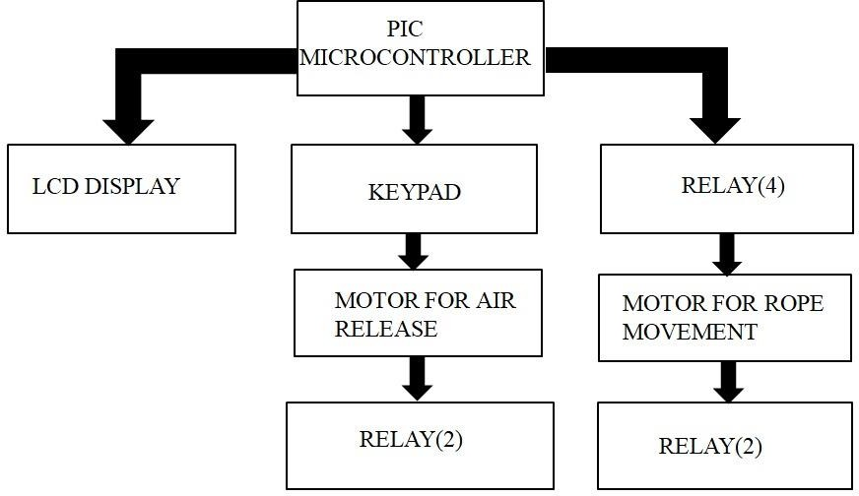

**Figure 4.1 Block Diagram of Equipment**

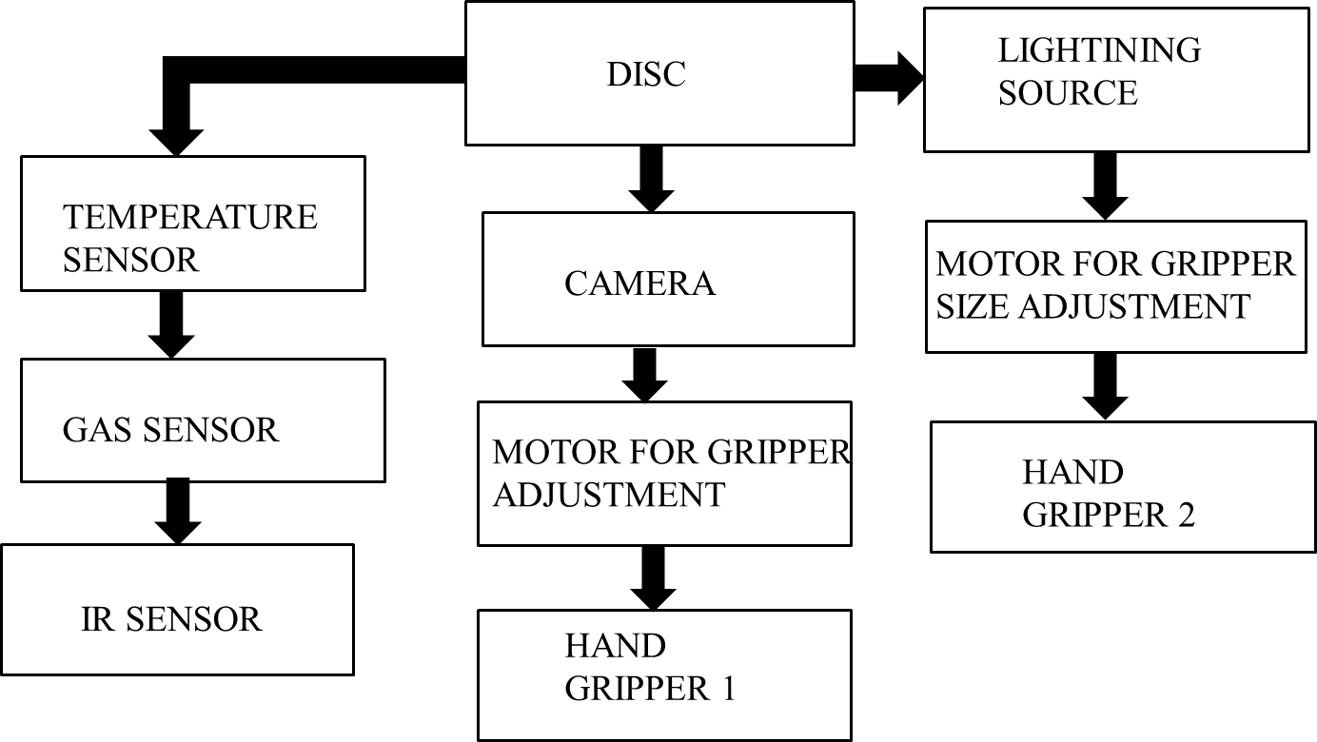

# Figure 4.2 Block diagram of Robotic Arm

* + 1. **PIC MICROCONTROLLER**

The microcontroller that has been used for this project is from the PIC series. PIC microcontroller is the first RISC-based microcontroller fabricated in CMOS (complementary metal oxide semiconductor) that uses a separate bus for instruction and data allowing simultaneous access of program and data memory.

The main advantage of CMOS and RISC combination is low power consumption resulting in a very small chip size with a small pin count reached 89%. IDBA, when under attack, gave a lower packet dropped rate as compared To BAODV and two detection algorithms i.e. ids AODV and EAODV. This can also be analysed from Fig.1 as the greater The PDR, the lower will be the rate of packets dropped. The main advantage of CMOS is that it has immunity to noise than other fabrication techniques.

The core features of PIC Microcontroller :

* + - 1. High-performance RISC CPU
      2. Only 35 single word instructions to learn
      3. All single cycle instructions except for program branches which are two cycle
      4. Operating speed: DC - 20 MHz clock input
      5. Up to 8K x 14 words of Flash Program Memory
      6. Up to 368 x 8 bytes of Data Memory (RAM)
      7. Up to 256 x 8 bytes of EEPROM data memory
      8. Pin out compatible to the PIC16C73/74/76/77
      9. Interrupt capability (up to 14 internal/external
      10. Eight level deep hardware stack
      11. Direct, indirect, and relative addressing modes
      12. Power-on Reset (POR)
      13. Power-up Timer (PWRT) and Oscillator Start-up Timer (OST) 14.Watchdog Timer (WDT) with its own on-chip RC Oscillator for reliable

operation

15.Programmable code-protection 16.Power saving SLEEP mode 17.Selectable oscillator options

18.Low-power, high-speed CMOS EPROM/EEPROM technology 19.Fully static design

# 4.1 TABLE SPECIFICATIONS

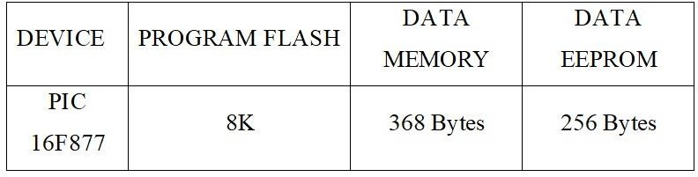

**Table 4.1 Specifications Of Microcontroller**

As mentioned above the PIC Microcontroller 16F877 with program flash 8K is utilized with 368 bytes and 265 bytes of data memory and data of EEPROM respectively

# 4.4 PIN DIAGRAM OF PIC 16F877A

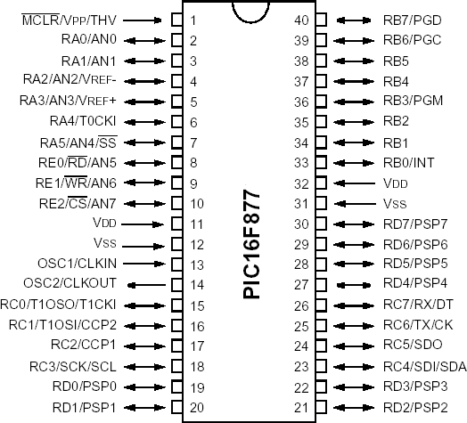

**Figure 4.3 Pin Diagram**

PIC16F877a is a 40-pin PIC Microcontroller, designed using RISC architecture, manufactured by Microchip and is used in Embedded Projects. It has five Ports on it, starting from Port A to Port E. It has three Timers in it, two of which are 8-bit Timers while 1 is of 16 Bit.

# PIN OUT DESCRIPTION-1

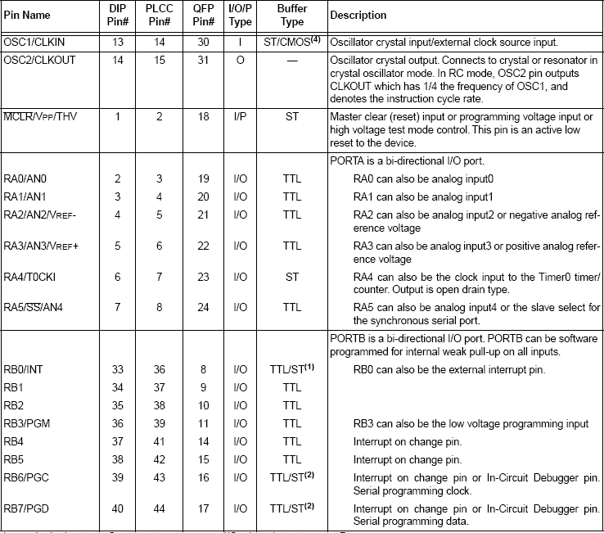

**Table 4.2 Pin out Description-1**

# PIN OUT DESCRIPTION-2

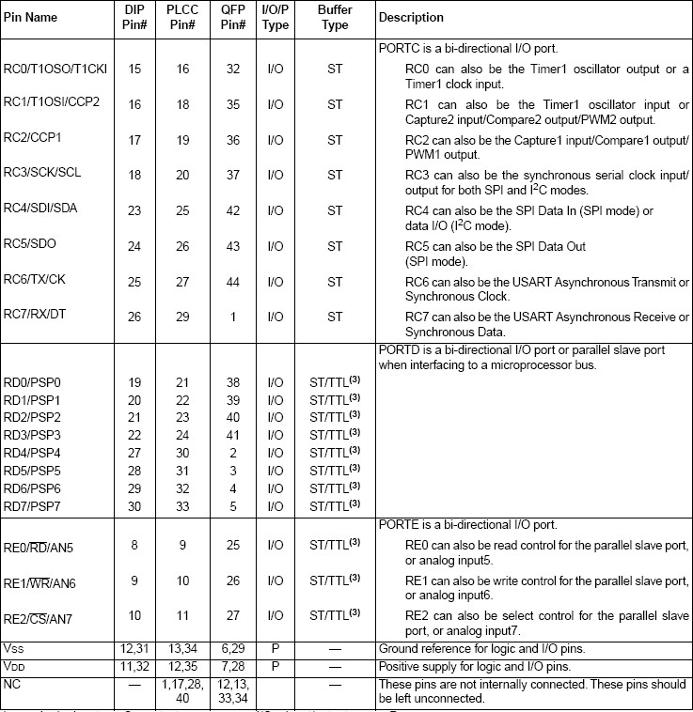

**Table 4.3 Pin out Description-2**

PIC16F877a has 5 Ports in total which are:

Port A has 6 Pins in total starting from Pin # 2 to Pin # 7. Port A Pins are labeled from RA0 to RA5 where RA0 is the label of the first Pin of Port A. Port B has 8 Pins in total starting from Pin # 33 to Pin # 40. Port B Pins are labeled from RB0 to RB7 where RB0 is the label of the first Pin of Port B. Port C has 8 Pins in total. Its pins are not aligned together. The first four Pins of Port C are located at Pin # 15 – Pin # 18, while the last four are located at Pin # 23 – Pin #

26. Port D has 8 Pins in total. Its pins are also not aligned together. The first four Pins of Port D are located at Pin # 19 – Pin # 22, while the last four are located at Pin # 27 – Pin # 30. Port E has 3 Pins in total starting from Pin # 8 to Pin # 10. Port E Pins are labeled from RE0 to RE2 where RE0 is the label of the first Pin of Port E.

# LIQUID CRYSTAL DISPLAY

Liquid crystal displays have materials, which combine the properties of both liquids and crystals. Rather than having a melting point, they have a temperature range within which the molecules are almost as mobile as they would be in a liquid, but are grouped together in an ordered form similar to a crystal.

An LCD consists of two glass panels, with the liquid crystal material sand witched in between them. The inner surface of the glass plates are coated with transparent electrodes which define the character, symbols or patterns to be displayed polymeric layers are present in between the electrodes and the liquid crystal, which makes the liquid crystal molecules to maintain a defined orientation angle.

# TEMPERATURE SENSOR

A thermistor (or thermal resistor) is defined as a type of resistor whose electrical resistance varies with changes in temperature. Although all resistor’s resistance will fluctuate slightly with temperature, a thermistor is particularly sensitive to temperature changes. Thermistors act as a [passive component](https://www.electrical4u.com/active-and-passive-elements-of-electrical-circuit/) in a circuit. They are an accurate, cheap, and robust way to measure temperature. While they do not work well in extremely hot or cold temperatures, they are the sensor of choice for many different applications. They are ideal when a precise temperature reading is required.

# RELAY OPERATION

A relay is an electrically operated switch. Current flowing through the coil of the relay creates a magnetic field which attracts a lever and changes the switch contacts. The coil current can be on or off so relays have two switch positions and they are double throw (changeover) switches. Relays allow one circuit to switch a second circuit which can be completely separate from the first. For example, a low voltage battery circuit can use a relay to switch a 230V AC mains circuit. There is no electrical connection inside the relay between the two circuits; the link is magnetic and mechanical.

# ALARM OPERATION

A buzzer or alarm is a signaling device, usually electronic, typically used in automobiles, household appliances such as a microwave oven, or game shows. It most commonly consists of a number of switches or sensors connected to a control unit that determines if and which button was pushed or a preset time has lapsed, and usually illuminates a light on the appropriate button or control panel, and sounds a warning in the form of a continuous or intermittent buzzing or beeping sound. Initially this device was based on an electromechanical system which was identical to an electric bell without the metal gong (which makes the ringing noise).

# 4.5 OVERALL CIRCUIT DIAGRAM DESCRIPTION

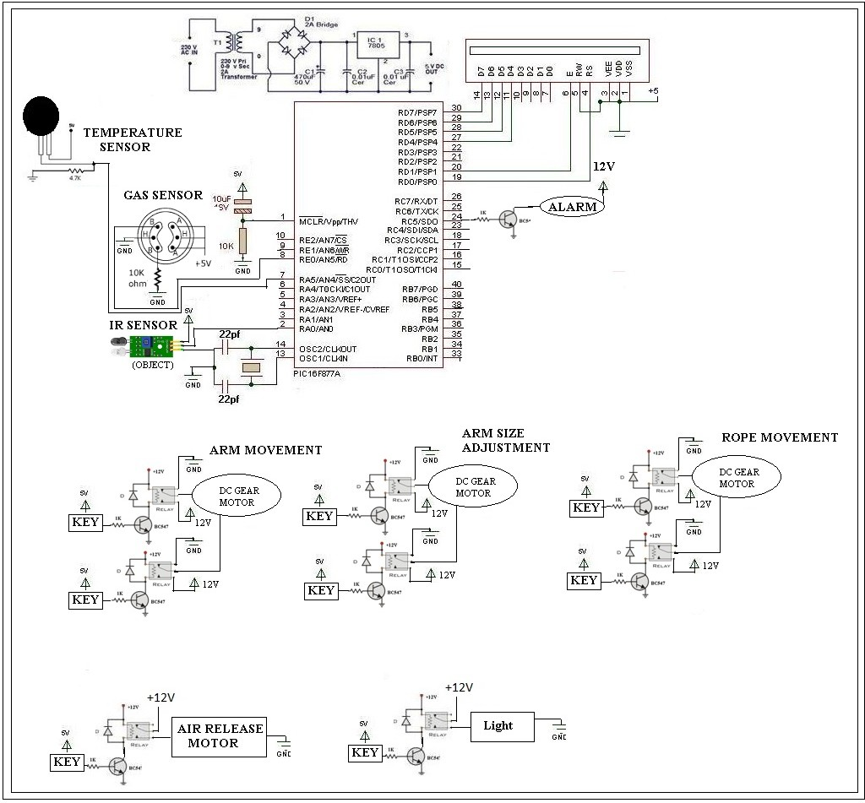

**Figure 4.4 Overall circuit diagram**

Based on the data carried by the sensors all the precautionary measures will be carried out. The required amount of oxygen and water supply will be provided to energize the child until the completion of the operation. The audio system present in the device is used to stable the mental health of the victim by

making interaction with them. When the robotic arm is properly placed to hold the child in a comfortable position the safety balloon will be released below the child to avoid falling and grip the child’s posture. Using the lifting rod, the child will be taken out of the hole gradually following the controller’s instruction from the ground. Once the child is lifted above the ground immediately the first aid process will be rushed up. The entire process of rescue will be caried out using Embedded C programming language and executed using MP lab IDE.

# POWER SUPPLY

The ac voltage, typically 220V rms, is connected to a transformer, which steps that ac voltage down to the level of the desired dc output. A diode rectifier then provides a full-wave rectified voltage that is initially filtered by a simple capacitor filter to produce a dc voltage. This resulting dc voltage usually has some ripple or ac voltage variation.

A regulator circuit removes the ripples and also remains the same dc value even if the input dc voltage varies, or the load connected to the output dc voltage changes. This voltage regulation is usually obtained using one of the popular voltage regulator IC units.

The transformer will step down the power supply voltage (0-230V) to (0-6V) level. Then the secondary of the potential transformer will be connected to the precision rectifier, which is constructed with the help of op–amp. The advantages of using precision rectifier are it will give peak voltage output as DC; rest of the circuits will give only RMS output.

# MICROCONTROLLER CIRCUIT

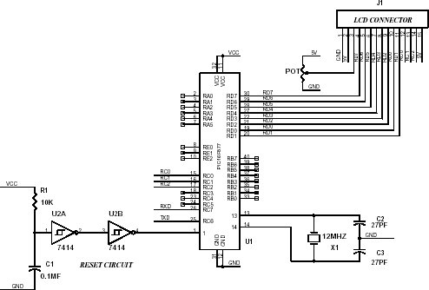

**Figure 4.5 PIC Microcontroller Circuit**

The microcontroller circuit is connected with reset circuit, crystal oscillator circuit, lcd circuit the reset circuit is the one which is an external interrupt which is designed to reset the program. And the crystal oscillator circuit is the one used to generate the pulses to microcontroller and it also called as the

heart of the microcontroller here we have used 12mhz crystal which generates pulses up to 12000000 frequency which is converted it machine cycle frequency when divided by 12 which is equal to 1000000hz to find the time we have to invert the frequency so that we get one micro second for each execution of the instruction.

The lcd that is liquid crystal display which is used to display the what we need the lcd has fourteen pins in which three pins for the command and eight pins for the data. If the data is given to lcd it is write command which is configured by the programmer otherwise it is read command in which data read to microcontroller the data pins are given to the to port0 and command pins are given to the port2. Other than these pin a one pin configured for the contrast of the lcd.

# IR SENSOR CIRCUIT

An infrared transmitter is one type of LED which emits infrared rays generally called as IR Transmitter. Similarly, IR Receiver is used to receive the IR rays transmitted by the IR transmitter. One important point is both IR transmitter and receiver should be placed straight line to each other.

Infrared transmitter is one type of LED which emits infrared rays generally called as IR Transmitter. Similarly, IR Receiver is used to receive the IR rays transmitted by the IR transmitter. One important point is both IR transmitter and receiver should be placed straight line to each other.

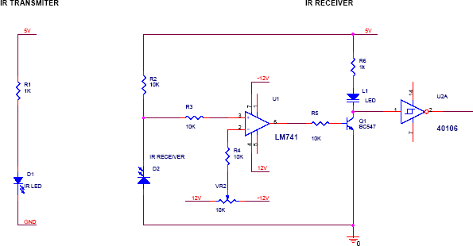

# Figure 4.6 IR Transmitter and Receiver

The transmitted signal is given to IR transmitter whenever the signal is high, the IR transmitter LED is conducting it passes the IR rays to the receiver. The IR receiver is connected with comparator. In the comparator circuit the reference voltage is given to inverting input terminal. The non-inverting input terminal is connected IR receiver.. Now the comparator output is in the range of

+12V. This voltage is given to base of the transistor Q1. Hence the transistor is conducting. Here the transistor is act as switch so the collector and emitter will be closed. The output is taken from collector terminal. Now the output is zero.

# RELAY DRIVER CIRCUIT

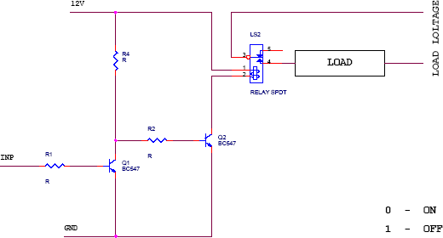

**Figure 4.7 Relay Driver Circuit**

A relay is an electrically operated switch. Current flowing through the coil of the relay creates a magnetic field which attracts a lever and changes the switch contacts. The coil current can be on or off so relays have two switch positions and they are double throw (changeover) switches. Relays allow one circuit to switch a second circuit which can be completely separate from the first. For example a low voltage battery circuit can use a relay to switch a 230V AC mains circuit. There is no electrical connection inside the relay between the two circuits; the link is magnetic and mechanical.

# ALARM CIRCUIT

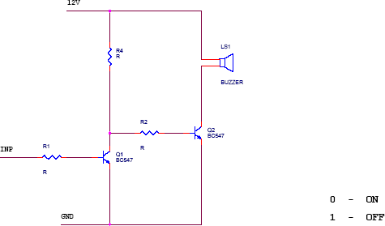

**Figure 4.8 Alarm Circuit**

A buzzer or alarm is a signaling device, usually electronic, typically used in automobiles, household appliances such as a microwave oven, or game shows. It most commonly consists of a number of switches or sensors connected to a control unit that determines if and which button was pushed or a preset time has lapsed, and usually illuminates a light on the appropriate button or control panel, and sounds a warning in the form of a continuous or intermittent buzzing or beeping sound. Initially this device was based on an electromechanical system which was identical to an electric bell without the metal gong (which makes the ringing noise).

# GAS SENSOR CIRCUIT

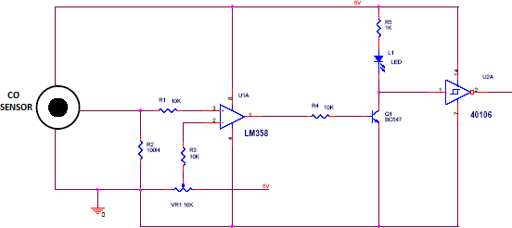

**Figure 4.9 Gas Sensor Circuit**

Ideal sensor for use to detect the presence of a dangerous CO leak in your car or in a service station, storage tank environment. This unit can be easily incorporated into an alarm unit, to sound an alarm or give a visual indication of the CO concentration. The sensor has excellent sensitivity combined with a quick response time. The sensor can also sense iso-butane, propane, LNG and cigarette smoke.

# PCB DESIGN

* + 1. **INTRODUCTION**

Printed circuit boards, or PCBs, form the core of electronic equipment domestic and industrial. Some of the areas where PCBs are intensively used are computers, process control, telecommunications and instrumentation.

# MANUFACTURING

The manufacturing process consists of two methods; print and etch, and print, plate and etch. The single sided PCBs are usually made using the print and etch method. The double sided plate through–hole (PTH) boards are made by the print plate and etch method.

The production of multi layer boards uses both the methods. The inner layers are printed and etch while the outer layers are produced by print, plate and etch after pressing the inner layers.

# PANELISATION

Here the schematic transformed in to the working positive/negative films. The circuit is repeated conveniently to accommodate economically as many circuits as possible in a panel, which can be operated in every sequence of subsequent steps in the PCB process. This is called panelization. For the PTH boards, the next operation is drilling.

# DRILLING

PCB drilling is a state of the art operation. Very small holes are drilled with high speed CNC drilling machines, giving a wall finish with less or no smear or epoxy, required for void free through hole plating.

# PLATING

The heart of the PCB manufacturing process. The holes drilled in the board are treated both mechanically and chemically before depositing the copper by the electro less copper platting process.

# ETCHING

Once a multiplayer board is drilled and electro less copper deposited, the image available in the form of a film is transferred on to the outside by photo printing using a dry film printing process. The boards are then electrolytic plated on to the circuit pattern with copper and tin. The tin-plated deposit serves an etch resist when copper in the unwanted area is removed by the conveyor’s spray etching machines with chemical etch ants. The etching machines are attached to an automatic dosing equipment, which analyses and controls etch ants concentrations

# SOLDER MASK

Since a PCB design may call for very close spacing between conductors, a solder mask has to be applied on the both sides of the circuitry to avoid the bridging of conductors. The solder mask ink is applied by screening. The ink is dried, exposed to UV, developed in a mild alkaline solution and finally cured by both UV and thermal energy.

# HOT AIR LEVELLING

After applying the solder mask, the circuit pads are soldered using the hot air levelling process. The bare bodies fluxed and dipped in to a molten solder bath. While removing the board from the solder bath, hot air is blown on both sides of the board through air knives in the machines, leaving the board soldered and leveled. This is one of the common finishes given to the boards. Thus the double sided plated through whole printed circuit board is manufactured and is now ready for the components to be soldered.

# FLOWCHART OF WORKING PRINCIPLE

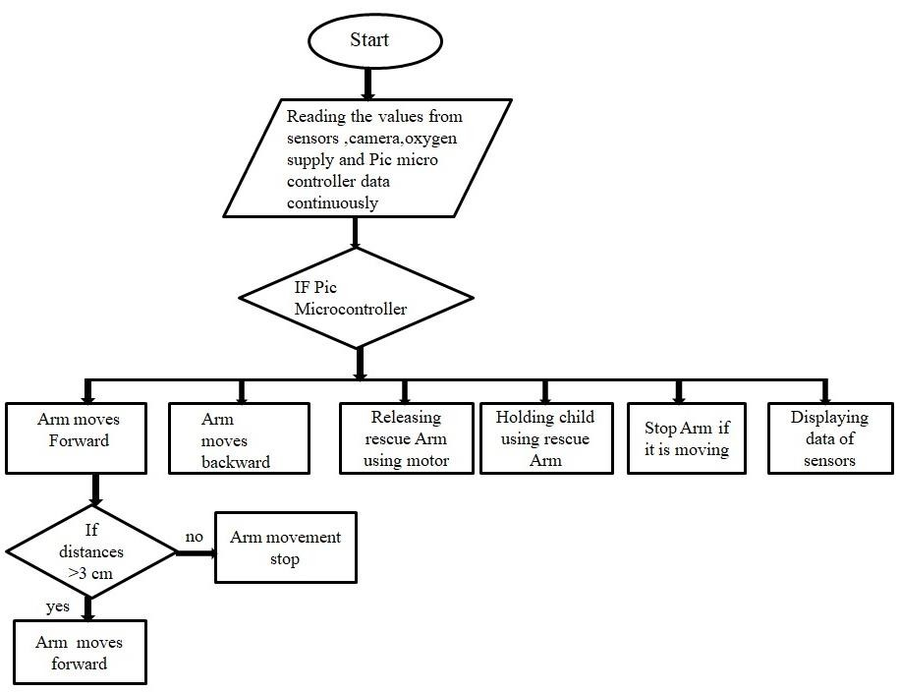

**Figure 4.10 Flowchart of Working Principle**

First the entire system is passed down the borewell. The IR sensor attached to the robot arm sense the distance of the victim from the opening of the borewell. This data is send with the help of PIC Microcontroller to PC the operator with the help of this data starts to move the arm downwards. Continuous monitoring of temperature, distance, gases and position is done by three sensors which are temperature, IR, gas sensor. With the help of this data we can decide when to supply the oxygen inside the borewell**.**

The data from PIC Microcontroller is read if forward button is pressed in the relay then the arm continues to move forward to reach the victim. If the if backward button is pressed in the relay then the pulley moves backward. When the arm reaches the victim to hold the child we release rescue arm using motor this will help to hold the child from shoulder. The child should be always held from shoulder as it is safe and pressure can be applied than any other part of child. And finally the data displayed with help of sensors. Continuous checking of distance is done for moving the arm forward. If the distance is greater than 3 cm the arm continue to move forward if it’s less then 3 cm the arm stop. The moment is continuously with the help of camera.

# SOFTWARE TOOLS

* + 1. **MPLAB**

MPLAB IDE is an integrated development environment that provides development engineers with the flexibility to develop and debug firmware for various Microchip devices

MPLAB IDE is a Windows-based Integrated Development Environment for the Microchip Technology Incorporated PIC microcontroller (MCU) and DSPIC digital signal controller (DSC) families. In the MPLAB IDE, you can:

* + - 1. Create source code using the built-in editor.
      2. Assemble, compile and link source code using various language tools. An assembler, linker and librarian come with MPLAB IDE. C compilers are available from Microchip and other third-party vendors.
      3. Debug the executable logic by watching program flow with a simulator, such as MPLAB SIM, or in real time with an emulator, such as MPLAB

ICE. Third party emulators that work with MPLAB IDE are also available.

* + - 1. Make timing measurements.
      2. View variables in Watch windows.
      3. Program firmware into devices with programmers such as PICSTART Plus or PRO MATE II.

# MPLAB SIMULATOR

MPLAB SIM is a discrete-event simulator for the PIC microcontroller (MCU) families. It is integrated into MPLAB IDE integrated development environment. The MPLAB SIM debugging tool is designed to model operation of Microchip Technology's PIC microcontrollers to assist users in debugging software for these devices

# IC PROG

The PRO MATE II is a Microchip microcontroller device programmer. Through interchangeable programming socket modules, PRO MATE II enables you to quickly and easily program the entire line of Microchip PIC micro microcontroller devices and many of the Microchip memory parts.

PRO MATE II may be used with MPLAB IDE running under supported Windows OS's , with the command-line controller PROCMD or as a stand-alone programmer.

# COMPILER-HIGH TECH C

A program written in the high-level language called C; which will be converted into PIC micro MCU machine code by a compiler. Machine code is suitable for use by a PIC micro MCU or Microchip development system product like MPLAB IDE.

# PIC START PLUS PROGRAMMER

The PIC start plus development system from microchip technology provides the product development engineer. The pic start plus development system includes PIC start plus development programmer and MPLAB IDE.

# CHAPTER 5 CONCLUSION

A great deal of lives has been lost because of falling in the bore well since it includes burrowing a pit close to a drag well which is a tedious procedure. The proposed framework is to conquer every one of these troubles by executing customizable distance across mechanical framework. This task is utilized to decrease human endeavours for safeguarding activities from bore well. It performs safeguard activities in less time when contrasted with customary techniques. The venture included air filler to supply oxygen without air. By actualizing this task in true we can spare the lives of child by saving them.

# 5.1 FUTURE SCOPE

This device is designed to withstand any weight and can also be adjusted to a variety of bore well diameters. In future we can use this project in several applications by adding additional components to this project. The structure is made strong enough to sustain all possible loads, though it can be flexible at the same time to adjust wider range of bore diameter and any change in the diameter of bore. We can send these robots to dangerous zones by connecting smoke sensor to the robot we can get the information related concentration of smoke or gases in respective fields and sensor will detect the poisonous gas and it gives information to the Microcontroller and microcontroller gives the information to the transceiver from that we can get the data on the PC side.

For undertaking demo concern, we have built up a model module. In future, this undertaking can be taken to the item level. To make this undertaking as easy to use and sturdy, we have to make it minimal and financially savvy. Going further, the majority of the units can be implanted alongside the controller on a solitary board with change in innovation, in this manner diminishing the span of the framework.

# REFERENCES

1. B. Bharathi, B. Suchitha Samuel, ‘Design and Construction of Rescue Robot and Pipeline Inspection Using Zigbee’, International Journal Of Scientific Engineering and Research (IJSER), vol. 1, no. 1, September 2013.
2. S. Gopinath, T. Devika, L. Manivannan, N. Suthanthira Vanitha, ‘Rescue Child from Bore well using Embedded System’, 2015.
3. John Jose pottery, ‘robot for bore well rescue’, amal jothi college of engineering, vol. 10, Jun 2009.
4. G Kavianand; K Gowri Ganesh ; P Karthikeyan, Smart child rescue system from borewell (SCRS), Published in: Emerging Trends in Engineering, Technology and Science (ICETETS), International Conference on , 24-26 Feb. 2016,IEEE Xplore: 24 October 2016
5. C. Kemp, A. Edsinger 2007, ‘Challenges for Robot Manipulation in Human Environments’, IEEE Robotics & Automation Magazine, 2007 pp. 229.
6. G. Nithin, G. Gowtham, G. Venkatachalam, and S. Narayanan ‘Design and Simulation of Bore well rescue robot’ Advanced School of Mechanical Building Sciences, VIT University, India, ARPN Journal of Engineering and Applied Sciences, pp. MAY 2014.
7. Pal winder kaur, Ravinder kaur, Gurpreet Singh, ‘Pipeline Inspection And Bore well Rescue Robot’, International Journal of Research In Engineering and Technology(IJRET), vol. 03, no. 04, April 2014.
8. Raj Manish, P. Chakraborty, G.C. Nandi, "Rescue robotics in bore well Environment", Cornell university library [v1] Mon, Jun 2014.
9. Dr. C.N. Sakhale, 2D.M. Mate Subhasis Saha, Tomar Dharmpal, Pranjit Kar, Arindam Sarkar, Roam Choudhury, Shahil Kumar, ‘An Approach to Design of Child Saver Machine for Child Trapped in Borehole’ International Journal of Research in Mechanical Engineering, October- December, 2013, pp. 26-38.
10. K. Saran1, S.Vignesh2, Marlon Jones Louis ‘Bore-well rescue robot’, International Journal of Research in Aeronautical and Mechanical Engineering, Boar well rescue robot, pp. 20-30 April 2014.
11. Sridhar Palaniswamy, "Life Saving Machine", first International Conference on Interdisciplinary Research and Development, 31May-1 June 2011.
12. V. Venatic, E. Poornima, S. Sumathi, ‘Borewell Rescue Robot’, International Journal of Computer Applications, vol. 113, no. 14, 2015.

# APPENDIX

#include <htc.h>

CONFIG (0x2F0A);

#define _XTAL_FREQ 8000000 #define rs RB0

#define rw RB1 #define en RB2

#define lcdport PORTB #define FFF RD0 #define BBB RD1 #define RRR RD2 #define LLL RD3 #define RELAY1 RC0 #define RELAY2 RC1 #define RELAY3 RC2 #define RELAY4 RC3 #define RELAY5 RC4

#define RELAY6 RC5

#define buzzer RC6 #define ir RC7

void lcd_ini();

void dis_cmd(unsigned char); void dis_data(unsigned char); void lcdcmd(unsigned char); void lcddata(unsigned char);

void lcd_data_string(unsigned char *str) ; void conv2(unsigned int count);

void init_a2d(void);

unsigned char read_a2d(unsigned char channel); unsigned int xx,yy,zz,ww,ss,bb,tt;

void conv(unsigned int count); void delay(unsigned int msec )

{

int i ,j ; for(i=0;i<msec;i++)

for(j=0; j<700; j++);

}

void init_a2d(void)

{

ADCON0=0; // select Fosc/2

ADCON1=0; // select left justify result. A/D port configuration 0 ADON=1; // turn on the A2D conversion module

}

unsigned char read_a2d(unsigned char channel)

{

channel&=0x07; // truncate channel to 3 bits ADCON0&=0xC5; // clear current channel select ADCON0|=(channel<<3); // apply the new channel select ADGO=1; // initiate conversion on the selected channel while(ADGO)continue;

return(ADRESH); // return 8 MSB of the result

}

void conv(unsigned int count)

{

unsigned int dig1,dig2,dig3,temp; dig1=count/100; dig1=dig1+=0x30; temp=count%100; dig2=temp/10;

dig2=dig2+0x30; dig3=count%10; dig3=dig3+0x30; dis_data(dig1); dis_data(dig2); dis_data(dig3);

}

void conv2(unsigned int count)

{

unsigned int dig1,dig2,dig3,temp; dig1=count/100; dig1=dig1+=0x30;

temp=count%100;

dig2=temp/10; dig2=dig2+0x30; dig3=count%10; dig3=dig3+0x30;

// dis_data(dig1); dis_data(dig2); dis_data(dig3);

}

void main(void)

{

TRISA=0xFF; TRISB=0x00; TRISC=0x80; TRISD=0xFF;

init_a2d();

lcd_ini(); // LCD initialization buzzer=0;

while(1)

{

tt=0; tt=read_a2d(0); tt=tt*2; dis_cmd(0x80);

lcd_data_string("T:"); conv(tt);

dis_data('o');dis_data('C'); ww=0;

ww=read_a2d(1); ww=ww*0.08*4; dis_cmd(0x89); lcd_data_string("G:");

conv2(ww); lcd_data_string (“ppm”);

f(tt>=50)

{

buzzer=1;

}

else

{

buzzer=0;

}

}

}

void lcd_ini()

{

dis_cmd(0x02); // To initialize LCD in 4-bit mode. dis_cmd(0x28); // To initialize LCD in 2 lines, 5x7 dots and

4bit mode.

dis_cmd(0x0C); dis_cmd(0x06); dis_cmd(0x80);

}

void dis_cmd(unsigned char cmd_value)

{

unsigned char cmd_value1;

cmd_value1 = (cmd_value & 0xF0); // Mask lower nibble because RB4-RB7 pins are being used

lcdcmd(cmd_value1); // Send to LCD

cmd_value1 = ((cmd_value<<4) & 0xF0); // Shift 4-bit and mask lcdcmd(cmd_value1); // Send to LCD

}

void dis_data(unsigned char data_value)

{

unsigned char data_value1; data_value1=(data_value&0xF0); lcddata(data_value1); data_value1=((data_value<<4)&0xF0); lcddata(data_value1);

}

void lcdcmd(unsigned char cmdout)

{

lcdport=cmdout; //Send command to lcdport=PORTB rs=0;

rw=0; en=1; delay(1); en=0;

}

void lcddata(unsigned char dataout)

{

lcdport=dataout; //Send data to lcdport=PORTB rs=1;

rw=0; en=1; delay(1); en=0;

}

void lcd_data_string(unsigned char *str)

{

int i=0; while(str[i]!='\0')

{

dis_data(str[i]); i++;

}

return;

}